**Bug Report for Travel Buddy Web Application/Website:**

**1.** **Bug Title**: Incorrect Navigation Behavior in Travel Buddy Experiences

**2. Severity/Priority**: High

**3. Description**: Upon clicking the "Day Experiences" option under the "Travel Buddy Experiences" menu in the Travel Buddy application, users are redirected to the "Travel Buddy Trips" page instead of the expected "Day Experiences" page. This issue occurs inconsistently, initially functioning correctly but later failing to navigate to the intended page.

Steps to Reproduce:

1. Launch the Travel Buddy application.

2. Navigate to the "Travel Buddy Experiences" option.

3. Click on the "Day Experiences" button.

4. Observe that the application redirects to the "Travel Buddy Trips" page instead of the expected "Day Experiences" page.

**4. Expected Behaviour**: When clicking on the "Day Experiences" button, the application should navigate to the "Day Experiences" page, displaying a list of available day experiences for the selected destination.

**5. Actual Behaviour**: Clicking on the "Day Experiences" button redirects users to the "Travel Buddy Trips" page instead of the intended "Day Experiences" page. The issue occurs inconsistently, initially functioning correctly but later failing to navigate correctly.

**6.Video**:



**Screenshots:**

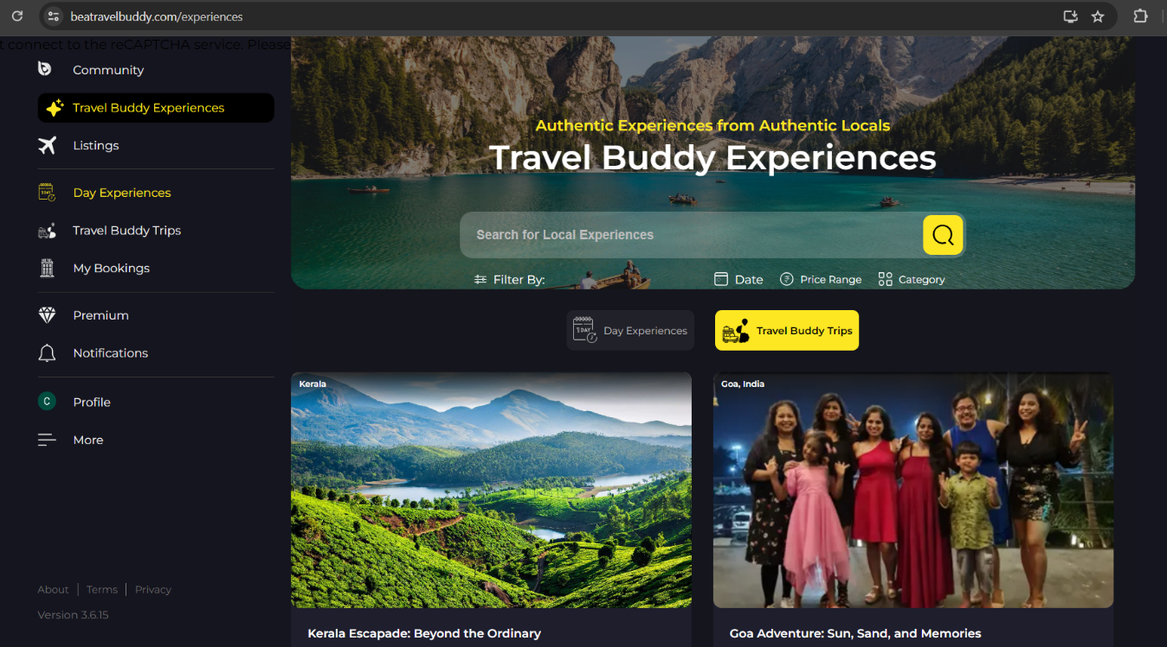

**Screenshot1 :** When clicked on “Day Experiences” option it is

showing “Travel Buddy Trips” page

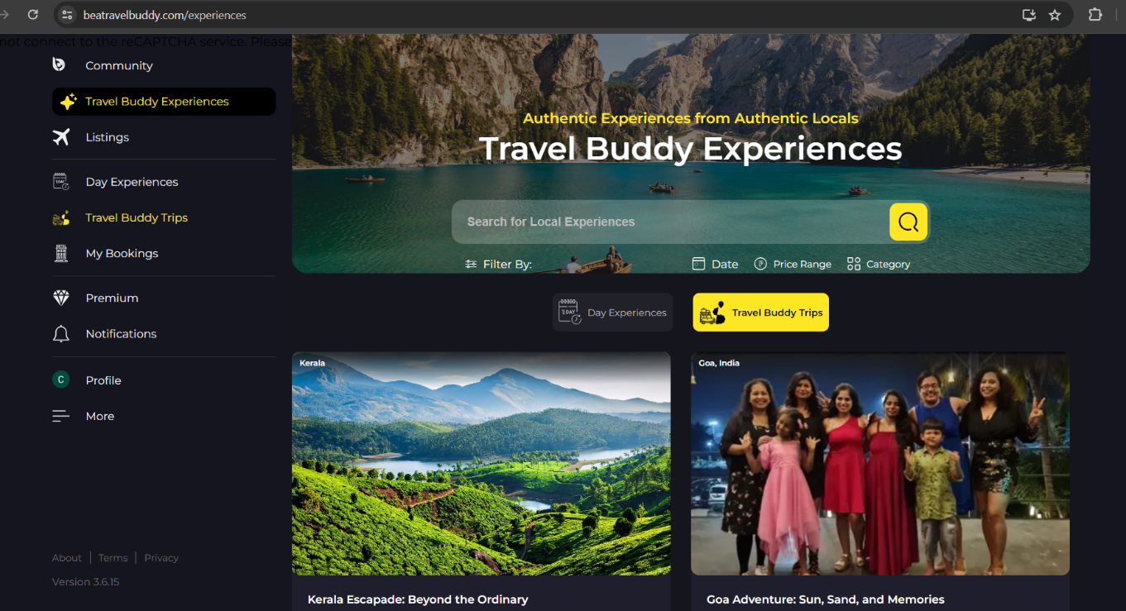

**Screenshot2 :**  When clicked on “Travel Buddy Trips” option it is

showing “Travel Buddy Trips” page(This is not the bug)

**7. Environment**:

- Browser: Chrome Version 98.0.4758.102

- Operating System: Windows 10

- Device: Desktop

**8. Additional Notes:**

- This issue occurs inconsistently, initially functioning correctly but later failing to navigate correctly, indicating a potential underlying problem with the application's navigation logic or state management.

- Users have reported confusion and frustration due to the unexpected redirection, impacting their ability to access and explore day experiences within the application.

- The incorrect navigation Behavior undermines the usability and functionality of the Travel Buddy Experiences feature, potentially leading to user dissatisfaction and decreased engagement with the application.